ABSTRACT

This project entitled “VIDEO STREAMING HUB” is a web application designed using Microsoft ASP .Net as front end and SQL Server as back end. VB.Net coding language is used to develop the project.

The project is concerned with video uploading and sharing activities. This helps users a lot in sharing the knowledge through video streaming. In this project the user needs to register his/her details into the site, so that he/she will avail the login id and password. Using the login details user login to the website and will perform video upload, stream, download and sharing.

Since this project is developed as a website, it provides the flexibility of working from remote locations with proper authentication. This helps users in sharing knowledge in the form of video. The web platform provide the advantage of searching right content with best key match and will also reduce redundant videos online. Thus this project helps user in gaining better knowledge online by providing required video content.

1. INTRODUCTION

1.1 ABOUT THE PROJECT
With the advent of social web initiatives, some argued that these new emerging tools might be useful in tacit knowledge sharing through providing interactive and collaborative technologies. However, there is still a poverty of literature to understand how and what might be the contributions of social media in facilitating tacit knowledge sharing Therefore, this project is intended to practically investigate and map social media concepts and characteristics with tacit knowledge creation and sharing requirements. By conducting a web portal, some major requirements found that need to be present in an environment that involves tacit knowledge sharing. These requirements have been analyzed against social media concepts and characteristics to see how they map together. The results showed that social media have abilities to comply some of the main requirements of tacit knowledge sharing. The relationships have been illustrated in a conceptual framework, suggesting further empirical studies to acknowledge findings of this study.

1.2 SYSTEM SPECIFICATION

1.2.1 HARDWARE CONFIGURATION

This section gives the details and specification of the hardware on which the system is expected to work.

Processor : Pentium Dual Core
Hard Disk Capacity : 80 GB
RAM : 2 GB RAM
Monitor : 15’ Color
Keyboard : 102 keys
Mouse : Optical Mouse

1.2.2 SOFTWARE CONFIGURATION

This section gives the details of the software that are used for the development.

Environment : Visual Studio
Web Technology : ASP.Net
Front-End : VB.Net.
Back-End : MS-SQL Server
Operating System : Windows 7
1.2.3 SELECTION OF SOFTWARE

THE .NET FRAMEWORK
The .NET Framework is a new computing platform that simplifies application development in the highly distributed environment of the Internet.

Objectives of .NET FRAMEWORK

1. To provide a consistent object-oriented programming environment whether object codes is stored and executed locally on Internet-distributed, or executed remotely.
2. To provide a code-execution environment to minimizes software deployment and guarantees safe execution of code.
3. Eliminates the performance problems.

There are different types of application, such as Windows-based applications and Web-based applications. To make communication on distributed environment to ensure that code be accessed by the .NET Framework can integrate with any other code.

COMPONENTS OF .NET FRAMEWORK

1. THE COMMON LANGUAGE RUNTIME (CLR)
The common language runtime is the foundation of the .NET Framework. It manages code at execution time, providing important services such as memory management, thread management, remoting and also ensures more security and robustness.

The concept of code management is a fundamental principle of the runtime. Code that targets the runtime is known as managed code, while code that does not target the runtime is known as unmanaged code.

THE .NET FRAME WORK CLASS LIBRARY

It is a comprehensive, object-oriented collection of reusable types used to develop applications ranging from traditional command-line or graphical user interface (GUI) applications to applications based on the latest innovations provided by ASP.NET, such as Web Forms and XML Web services.

The .NET Framework can be hosted by unmanaged components that load the common language runtime into their processes and initiate the execution of managed code, thereby creating a software environment that can exploit both managed and unmanaged features. The .NET Framework not only provides several runtime hosts, but also supports the development of third-party runtime hosts.

Internet Explorer is an example of an unmanaged application that hosts the runtime (in the form of a MIME type extension). Using Internet Explorer to host the runtime to enables embeds managed components or Windows Forms controls in HTML documents.

FEATURES OF THE COMMON LANGUAGE RUNTIME

The common language runtime manages memory; thread execution, code execution, code safety verification, compilation, and other system services these are all run on CLR.

- Security.
- Robustness.
- Productivity.
- Performance.

Security
The runtime enforces code access security. The security features of the runtime thus enable legitimate Internet-deployed software to be exceptionally feature rich. With regards to security, managed components are awarded varying degrees of trust, depending on a number of factors that include their origin to perform file-access operations, registry-access operations, or other sensitive functions.

ROBUSTNESS
The runtime also enforces code robustness by implementing a strict type- and code-verification infrastructure called the common type system(CTS). The CTS ensures that all managed code is self-describing. The managed environment of the runtime eliminates many common software issues.

PRODUCTIVITY
The runtime also accelerates developer productivity. For example, programmers can write applications in their development language of choice, yet take full advantage of the runtime, the class library, and components written in other languages by other developers.

PERFORMANCE
The runtime is designed to enhance performance. Although the common language runtime provides many standard runtime services, managed code is never interpreted. A feature called just-in-time (JIT) compiling enables all managed code to run in the native machine language of the system on which it is executing. Finally, the runtime can be hosted by high-performance, server-side applications, such as Microsoft® SQL Server™ and Internet Information Services (IIS).

DATA ACCESS WITH ADO.NET
As you develop applications using ADO.NET, you will have different requirements for working with data. You might never need to directly edit an XML file containing data - but it is very useful to understand the data architecture in ADO.NET.
ADO.NET offers several advantages over previous versions of ADO:

- Interoperability
- Maintainability
- Programmability
- Performance Scalability

INTEROPERABILITY
ADO.NET applications can take advantage of the flexibility and broad acceptance of XML. Because XML is the format for transmitting datasets across the network, any component that can read the XML format can process data. The receiving component need not be an ADO.NET component.
The transmitting component can simply transmit the dataset to its destination without regard to how the receiving component is implemented. The destination component might be a Visual Studio application or any other application implemented with any tool whatsoever.
The only requirement is that the receiving component be able to read XML. SO, XML was designed with exactly this kind of interoperability in mind.

MAINTAINABILITY
In the life of a deployed system, modest changes are possible, but substantial, Architectural changes are rarely attempted because they are so difficult. As the performance load on a deployed application server grows, system resources can become scarce and response time or throughput can suffer. Faced with this problem, software architects can choose to divide the server's business-logic processing and user-interface processing onto separate tiers on separate machines.

In effect, the application server tier is replaced with two tiers, alleviating the shortage of system resources. If the original application is implemented in ADO.NET using datasets, this transformation is made easier. ADO.NET data components in Visual Studio encapsulate data access functionality in various ways that help you program more quickly and with fewer mistakes.

PERFORMANCE
ADO.NET datasets offer performance advantages over ADO disconnected record sets. In ADO.NET data-type conversion is not necessary.

SCALABILITY
ADO.NET accommodates scalability by encouraging programmers to conserve limited resources. Any ADO.NET application employs disconnected access to data; it does not retain database locks or active database connections for long durations.

VISUAL STUDIO .NET
Visual Studio .NET is a complete set of development tools for building ASP Web applications, XML Web services, desktop applications, and mobile applications In addition to building high-performing desktop applications, you can use Visual Studio's powerful component-based development tools and other technologies to simplify team-based design, development, and deployment of Enterprise solutions.

Visual Basic .NET, Visual C++ .NET, and Visual C# .NET all use the same integrated development environment (IDE), which allows them to share tools and facilitates in the creation of mixed-language solutions. In addition, these languages leverage the functionality of the .NET Framework and simplify the development of ASP Web applications and XML Web services.

Visual Studio supports the .NET Framework, which provides a common language runtime and unified programming classes; ASP.NET uses these components to create ASP Web applications and XML Web services. Also it includes MSDN Library, which contains all the documentation for these development tools.

COMMON LANGUAGE SPECIFICATION (CLS)
Visual Basic.NET is also compliant with CLS (Common Language Specification) and supports structured exception handling. CLS is set of rules and constructs that are supported by the CLR (Common Language Runtime). CLR is the runtime environment provided by the .NET Framework; it manages the execution of the code and also makes the development process easier by providing services.

Visual Basic .NET is a CLS-compliant language. Any objects, classes, or components that created in Visual Basic .NET can be used in any other CLS-compliant language. In addition, we can use objects, classes, and components created in other CLS-compliant languages in Visual Basic.NET .The use of CLS ensures complete interoperability among applications, regardless of the languages used to create the application.

IMPLEMENTATION INHERITANCE

Visual Basic.NET supports implementation inheritance. This means that, while creating applications in Visual Basic. NET, we can drive from another class, which is known as the base class that derived class inherits all the methods and properties of the base class. In the derived class, we can either use the existing code of the base class or override the existing code. Therefore, with help of the implementation inheritance, code can be reused.

CONSTRUCTORS AND DESTRUCTORS
Constructors are used to initialize objects, whereas destructors are used to destroy them. In other words, destructors are used to release the resources allocated to the object. In Visual Basic.NET the sub finalize procedure is available. The sub finalize procedure is used to complete the tasks that must be performed when an object is destroyed. The sub finalize procedure is called automatically when an object is destroyed. In addition, the sub finalize procedure can be called only from the class it belongs to or from derived classes.

GARBAGE COLLECTION
Garbage Collection is another new feature in Visual Basic.NET. The .NET Framework monitors allocated resources, such as objects and variables. In addition, the .NET Framework automatically releases memory for reuse by destroying objects that are no longer in use. In Visual Basic.NET, the garbage collector checks for the objects that are not currently in use by applications. When the garbage collector comes across an object that is marked for garbage collection, it releases the memory occupied by the object.

OVERLOADING
Overloading is another feature in Visual Basic .NET. Overloading enables us to define multiple procedures with the same name, where each procedure has a different set of arguments. Besides using overloading for procedures, we can use it for constructors and properties in a class.

MULTITHREADING
Visual Basic .NET also supports multithreading. An application that supports multithreading can handle multiple tasks simultaneously, we can use multithreading to decrease the time taken by an application to respond to user interaction. To decrease the time taken by an application to respond to user interaction, we must ensure that a separate thread in the application handles user interaction.

STRUCTURED EXCEPTION HANDLING
Visual Basic .NET supports structured handling, which enables us to detect and remove errors at runtime. In Visual Basic .NET, we need to use Try…Catch…Finally statements to create exception handlers. Using Try…Catch…Finally statements, we can create robust and effective exception handlers to improve the performance of our application.

ASP.NET
ASP.NET is a web application framework developed and marketed by Microsoft to allow programmers to build dynamic web sites, web applications and web services.
It was first released in January 2002 with version 1.0 of the .NET Framework, and is the successor to Microsoft's Active Server Pages (ASP) technology. ASP.NET is built on the Common Language Runtime (CLR), allowing programmers to write ASP.NET code using any supported .NET language. The ASP.NET SOAP extension framework allows ASP.NET components to process SOAP messages.

ADVANTAGES OF USING ASP.NET
- ASP.NET drastically reduces the amount of code required to built large applications.
- ASP.NET makes development simpler and easier to maintain with an event-driven, Server-side programming mode.
- ASP.NET pages are easy to write and maintain because the source code and HTML are together.
- The source code is executed on the server. The pages have lots of power and Flexibility by this approach.

CODE-BEHIND MODEL
Microsoft recommends dealing with dynamic program code by using the code-behind model, which places this code in a separate file or in a specially designated script tag. Code-behind files typically have names like default, while the page file is MyPage.aspx (same filename as the page file (ASPX), but with the final extension denoting the page language). This practice is automatic in Microsoft Visual Studio and other IDEs. When using this style of programming, the developer writes code to respond to different events, like the page being loaded, or a control being clicked, rather than a procedural walk through the document. ASP.NET's code-behind model marks a departure from Classic ASP in that it encourages developers to build applications with separation of presentation and content in mind. In theory, this would allow a web designer, for example, to focus on the design markup with less potential for disturbing the programming code that drives it. This is similar to the separation of the controller from the view in model-view-controller frameworks.

FEATURES OF SQL-SERVER
Microsoft SQL Server is a relational model database server produced by Microsoft. Its primary query languages are T-SQL and ANSI SQL.The OLAP Services feature available in SQL Server version 7.0 is now called SQL Server 2000 Analysis Services. The term OLAP Services has been replaced with the term Analysis Services. Analysis Services also includes a new data mining component. The Repository component available in SQL Server version 7.0 is now called Microsoft SQL Server 2000 Meta Data Services. References to the component now use the term Meta Data Services. The term repository is used only in reference to the repository engine within Meta Data Services

INTERNET INTEGRATION
The SQL Server 2000 database engine includes integrated XML support. It also has the scalability, availability, and security features required to operate as the data storage component of the largest Web sites. The SQL Server 2000 programming model is integrated with the Windows DNA architecture for developing Web applications, and SQL Server 2000 supports features such as English Query and the Microsoft Search Service to incorporate user-friendly queries and powerful search capabilities in Web applications.

SCALABILITY AND AVAILABILITY
The same database engine can be used across platforms ranging from laptop computers running Microsoft Windows® 98 through large, multiprocessor servers running Microsoft Windows 2000 Data Center Edition. SQL Server 2000 Enterprise Edition supports features such as federated servers, indexed views, and large memory support that allow it to scale to the performance levels required by the largest Web sites.

ENTERPRISE-LEVEL DATABASE FEATURES
The SQL Server 2000 relational database engine supports the features required to support demanding data processing environments. The database engine protects data integrity while minimizing the overhead of managing thousands of users concurrently modifying the database. SQL Server 2000 distributed queries allow you to reference data from multiple sources as if it were a part of a SQL Server 2000 database, while at the same time, the distributed transaction support protects the integrity of any updates of the distributed data. Replication allows you to also maintain multiple copies of data, while ensuring that the separate copies remain synchronized. You can replicate a set of data to multiple, mobile, disconnected users, have them work autonomously, and then merge their modifications back to the publisher.

EASE OF INSTALLATION, DEPLOYMENT, AND USE
SQL Server 2000 includes a set of administrative and development tools that improve upon the process of installing, deploying, managing, and using SQL Server across several sites. SQL Server 2000 also supports a standards-based programming model integrated with the Windows DNA, making the use of SQL Server databases and data warehouses a seamless part of building powerful and scalable systems. These features allow you to rapidly deliver SQL Server applications that customers can implement with a minimum of installation and administrative overhead.

DATA WAREHOUSING
SQL Server 2000 includes tools for extracting and analyzing summary data for online analytical processing. SQL Server also includes tools for visually designing databases and analyzing data using English-based questions.

2. SYSTEM STUDY

2.1 EXISTING SYSTEM
In existing system, we can only upload the videos and play the video online. We cannot share or download the required video. To overcome this disadvantage, we move to proposed system.
2.1.1 DRAWBACKS OF EXISTING SYSTEM
- Need to install additional plug-in for downloading video.
- Unable share the videos in other group.
- Privacy in video sharing is not possible.
- Redundancy can’t be avoided
- Have size restrictions.

2.2 PROPOSED SYSTEM
The proposed system is web application. Here, as usual user can upload the video and play online. The advantage is that user can download the video and also can share the videos. In addition to that, it improves security.

2.2.1 ADVANTAGES OF PROPOSED SYSTEM
- Required videos can be downloaded instantly without any additional software or plug-in.
- Sharing videos among the group is possible
- No need of additional application.
- Allows privacy to restrict
- No size restriction.
- Avoids redundant video uploads.

3. SYSTEM DESIGN AND DEVELOPMENT

3.1 INPUT DESIGN

Input Design is one of the most expensive phases of the operation of computerized system and it is often the major problem of a system. A large number of problems with a system can usually be tracked backs to fault input design and method. Needless to say, therefore, that the input data is the life blood of a system and have to be analyzed and designed with utmost case and consideration. The decisions made during the input design are,
- To provide cost effective method of input.
- To achieve the highest possible level of accuracy.
- To ensure that the input is understand by the user.

System analysis decide the following input design details like, what data to input, what medium to use, how the data should be arranged or coded, data items and transactions needing validations to detect errors and at last the dialogue to guide user in providing input.

Input data of a system may not be necessarily is raw data captured in the system from scratch. These can also be the output of another system or subsystem. The design of input covers all the phases of input from the creation of initial data to actual entering of the data to the system for processing. The design of inputs involves identifying the data needed, specifying the characteristics of each data item, capturing and preparing data from computer processing and ensuring correctness of data.

Input design is the process of converting user-originated inputs to a computer-based format. Input design is one of the most expensive phases of the operation of computerized system and is often the major problem of a system. Any Ambiguity in input leads to a total fault in output. The goal of designing the input data is to make data entry as easy and error free as possible.
INPUT FORMS
REGISTRATION
In this module, users register their details which include the parameter such as user id, username, gender, address, contact no, email, password and status using grid view control. These details are saved into the database with help of SQL server. Only after the registration they can share and download the videos from the group.
CREATE GROUP
In this module, user makes the request for group creation which includes the parameter such as request id, request date, group id, group name, user id, username and status. These details are saved into the database with help of SQL server. Only after the approval of admin user can sharing the videos in their group.
SEND REQUEST TO JOIN GROUP
In this module, user makes the request to join for others group which includes the parameter such as group id, user id and status. These details are saved into the database with help of SQL server. Only after the approval of group admin user can sharing the videos in their group.
UPLOAD VIDEOS
In this module, user can upload the videos in their group. It includes the parameter such as video id, video name, group id, user id, username, posted date, duration and description about video. These details are saved into the database with help of SQL server. These details are viewed by members in the group.
3.2 OUTPUT DESIGN

Computer output is the most important direct source of information to the user. Outputs computers are required primarily to communicate the results of processing to the users. They are also used to provide permanent copy of these results for rate reference. Thus it is designed in a user –friendly way to avoid user burden.
The output design refers to the results and information that is generated by the system forms many end users. To produce the outputs which are displayed in a screen. Efficient and intelligent output design improves the system relationships with the users and help in decision making. The output of the system is in the form of reports. The following reports are generated in the system.

OUTPUT FORMS
REGISTERED USER LIST
In this module, admin views the registered user details which include the parameter such as user id, username, gender, address, contact no, email, password and status using grid view control. These details are fetched from ‘user table’.
APPROVE/VIEW GROUP REQUEST
In this module, admin approves the group request made by user which includes the parameter such as request id, request date, group id, group name, user id, username and status. These details are fetched from database with help of SQL server and viewed by using grid view control.
UPLOADED VIDEOS LIST
In this module, admin view the user uploaded videos which include the parameter such as video id, video name, group id, user id, username, posted date, duration and description about video. These details are fetched from database with help of SQL server and viewed by grid view control.
3.3 DATABASE DESIGN

The most important consideration in designing the database is how information will be used. The main objectives of designing a database are:

Data Integration:
In a database, information from several files are coordinated, accessed and operated upon as through it is in a single file. Logically, the information are centralized, physically, the data may be located on different devices, connected through data communication facilities.

Data Integrity
Data integrity means storing all data in one place only and how each application to access it. This approach results in more consistent information, one update being sufficient to achieve a new record status for all applications, which use it. This leads to less data redundancy; data items need not be duplicated; a reduction in the direct access storage requirement.

Data Independence:
Data independence is the insulation of application programs from changing aspects of physical data organization. This objective seeks to allow changes in the content and organization of physical data without reprogramming of applications and to allow modifications to application programs without reorganizing the physical data.
The tables needed for each module were designed and the specification of each and every column was given based on the records and details collected during record specification of the system study.

TABLE STRUCTURE
Table Name : Admin
Description : Used to store the login details.
FIELD NAME | TYPE | SIZE | CONSTRAINTS
Username | varchar | 10 | Primary key
Password | varchar | 20 | Not Null

Table Name : User
Description : Used to store the user details.
FIELD NAME | TYPE | SIZE | CONSTRAINTS
UserID | Varchar | 50 | Primary Key
UserName | Varchar | 50 | Not Null
Gender | Varchar | 50 | Foreign Key
Address | Varchar | 250 | Not Null
ContactNo | Varchar | 50 | Foreign Key
Email | Varchar | 50 | Not Null
Password | Varchar | 50 | Not Null
Status | Varchar | 50 | Not Null

Table Name : Group Master
Description : Used to store the group details.
FIELD NAME | TYPE | SIZE | CONSTRAINTS
GroupID | Varchar | 50 | Primary Key
GroupName | Varchar | 50 | Not Null
AdminID | Varchar | 50 | Foreign Key
AdminName | Varchar | 50 | Not Null
Description | Varchar | 500 | Not Null
Status | Varchar | 50 | Not Null

Table Name : Group Trans
Description : Used to store the group Trans details.
FIELD NAME | TYPE | SIZE | CONSTRAINTS
RequestId | Varchar | 50 | Primary Key
RequestDate | DateTime | 8 | Not Null
GroupId | Varchar | 50 | Foreign Key
GroupName | Varchar | 50 | Not Null
UserId | Varchar | 50 | Foreign Key
UserName | Varchar | 50 | Not Null
Status | Varchar | 50 | Not Null

Table Name : Video
Description : Used to store the uploaded video details.
FIELD NAME | TYPE | SIZE | CONSTRAINTS
VideoId | Varchar | 50 | Primary Key
VideoName | Varchar | 100 | Not Null
GroupId | Varchar | 50 | Foreign Key
UserId | Varchar | 50 | Foreign Key
UserName | Varchar | 50 | Not Null
PostedDate | DateTime | 8 | Not Null
Duration | Varchar | 50 | Not Null
AboutVideo | Varchar | 500 | Not Null

Table Name : Tag
Description : Used to store tagged video details.
FIELD NAME | TYPE | SIZE | CONSTRAINTS
TagID | varchar | 10 | Primary key
VideoID | varchar | 20 | Not Null
UserID | varchar | 10 | Not Null
TaggerID | varchar | 10 | Not Null
3.4 SYSTEM DEVELOPMENT

3.4.1 DESCRIPTION OF MODULES
ADMIN
- VIEW GROUP REQUEST
- APPROVE REQUEST
- REGISTERED USER LIST
- UPLOADED VIDEO LIST
USER
- REGISTRATION
- CREATE GROUP
- UPLOAD VIDEOS
- SEND REQUEST TO JOIN GROUP
- APPROVE OTHERS REQUEST FOR JOINING
- DOWNLOAD VIDEOS

ADMIN MODULE
REGISTERED USER LIST
In this module, admin views the registered user details which include the parameter such as user id, username, gender, address, contact no, email, password and status using grid view control. These details are fetched from ‘user table’.
APPROVE/VIEW GROUP REQUEST
In this module, admin approves the group request made by user which includes the parameter such as request id, request date, group id, group name, user id, username and status. These details are fetched from database with help of SQL server and viewed by using grid view control.
UPLOADED VIDEOS LIST
In this module, admin view the user uploaded videos which include the parameter such as video id, video name, group id, user id, username, posted date, duration and description about video. These details are fetched from database with help of SQL server and viewed by grid view control.

USER MODULE
REGISTRATION
In this module, users register their details which include the parameter such as user id, username, gender, address, contact no, email, password and status using grid view control. These details are saved into the database with help of SQL server. Only after the registration they can share and download the videos from the group.
CREATE GROUP
In this module, user makes the request for group creation which includes the parameter such as request id, request date, group id, group name, user id, username and status. These details are saved into the database with help of SQL server. Only after the approval of admin user can sharing the videos in their group.
SEND REQUEST TO JOIN GROUP
In this module, user makes the request to join for others group which includes the parameter such as group id, user id and status. These details are saved into the database with help of SQL server. Only after the approval of group admin user can sharing the videos in their group.
APPROVE OTHERS REQUEST FOR JOINING
In this module, group admin approves the group request made by user which includes the parameter such as group id, user id and status. These details are fetched from database with help of SQL server and viewed by using grid view control.
UPLOAD VIDEOS
In this module, user can upload the videos in their group. It includes the parameter such as video id, video name, group id, user id, username, posted date, duration and description about video. These details are saved into the database with help of SQL server. These details are viewed by members in the group.
DOWNLOAD VIDEOS
In this module, user can download the video which include the parameter such as video id, video name, group id, user id, username, posted date and duration. Through this website group members can easily download the required videos. In addition to that, they can send their opinion for this video through this website itself.

4. SYSTEM TESTING AND IMPLEMENTATION

4.1 SYSTEM TESTING

After the source code has been completed, documented as related data structures. Completion of the project has to undergo testing and validation where there is subtitle and definite attempt to get errors. The project developer treats lightly, designing and execution of the project test that will demonstrates that the program works rather than uncovering errors, unfortunately errors will be present and if the project developer doesn’t found errors, the user will find out.

The project developer is always responsible for testing the individual units i.e. modules of the program. In many cases, developer should conduct the integration testing i.e. the testing step that leads to the construction of the complete program structure.

This project has undergone the following testing procedures to ensure its correctness.

- UNIT TESTING
- INTEGRATION TESTING
- VALIDATION TESTING

UNIT TESTING
In unit testing, user has to test the programs making up the system. For this reason, Unit testing sometimes called as Program testing. The software units in a system are the modules and routines that are assembled and integrated to perform a specific function.
In this project, all modules are tested individually like given all the fields and can be updated for all criteria.
INTEGRATION TESTING
Integration testing is a systematic technique for constructing the program structure. While at the same time conducting tests to uncover errors associated with interfacing. The objective is to take unit tested modules and build a program structure that has been dictated by design.
In this integration testing its done using the main module and based on the type of integration testing the subordinate tables and other criteria along with their path, is replaced one at a time with actual modules.
In the project, after integrating the all modules like complaint and service update are tested with their integration and that could integrated and manipulated with respect to the to and fro in between modules.

VALIDATION TESTING
It is said that validation is successful when the software functions in a systematic manner that can be reasonably accepted by the customers. This type of testing is very important because it is the only way to check whether the requirements given by user have been completely fulfilled.

The input given to various forms are validated effectively. The input is given for complaints details and service details. Each module is tested independently. In this project, code, username and password are validated successfully.

4.2 SYSTEM IMPLEMENTATION

When the initial design was done for the system, the client was consulted for the acceptance of the design so that further proceedings of the system development can be carried on. After the development of the system a demonstration was given to them about the working of the system. The aim of the system illustration was to identify any malfunction of the system.

After the management of the system was approved the system implemented in the concern, initially the system was run parallel with existing manual system. The system has been tested with live data and has proved to be error free and user friendly. Implementation is the process of converting a new or revised system design into an operational one when the initial design was done by the system; a demonstration was given to the end user about the working system. This process is uses to verify and identify any logical mess working of the system by feeding various combinations of test data.

After the approval of the system by both end user and management the system was implemented. A product software implementation method is a blueprint to get users and/or organizations running with a specific software product. The method is a set of rules and views to cope with the most common issues that occur when implementing a software product: business alignment from the organizational view and acceptance from the human view.

The implementation of product software, as the final link in the deployment chain of software production, is in a financial perspective of a major issue. The Implementation methodology includes four phases - Discovery, System Development, User Acceptance Testing and Production Rollout. It’s easy to be overwhelmed by slick marketing presentations, particularly when the sales force is talking about things that most people don’t completely understand. Showmanship gets in the way of real capabilities. Unless the review team is judging each vendor against the same list of needs, with the same understanding of the significance of each rating, “likeability” can win over capability.
These implementation phases are designed to provide clients with a seamless transition from an existing electronic or paper-based system to Sigmund while ensuring all aspects of a client’s operations are accounted for by the software. The Sigmund project team, comprised of individuals with clinical, billing and operations experience, is equipped with the skills and tools to manage the entire process from system requirements gathering to deployment. Sigmund provides various levels of support, depending on client needs, including client-side Project Management.
The Discovery Phase is preceded by a Project Kick-off Work-session that includes application demonstrations, completion and review of requirements and configuration questionnaires, identification of key client documentation, as well as consultation on possible process re-engineering needs. The Project Kick-off provides your organization with the opportunity to not only introduce the Sigmund Project Team to your organization, but also to define and structure your organization’s Project Team.
System implementation is made up of many activities. The six major activities are as follows.

CODING
Coding is the process of whereby the physical design specifications created by the analysis team turned into working computer code by the programming team.

INSTALLATION
Installation is the process during which the current system is replaced by the new system. This includes conversion of existing data, software, and documentation and work procedures to those consistent with the new system.

DOCUMENTATION
It is result from the installation process, user guides provides the information of how the use the system and its flow.

TRAINING AND SUPPORT
Training plan is a strategy for training user so they quickly learn to the new system. The development of the training plan probably began earlier in the project. As part of the proven implementation methodology, every customer gets Administrator Training for each of the applications they're implementing. The trainer will deliver the Administrator Training on-site, face-to-face, to a maximum of system administrators, so each learner gets personalized attention and can ask and get specific answers to questions. If it's more convenient for them and they can be offered the training facilities.
5. CONCLUSION
The new system eliminates the difficulties in the existing system. It is developed in a user friendly manner. The aim of the project is to improve the process of videos streaming through website. It minimizes the time consumption. It is concluded that the application works well and satisfy the user. The application is tested very well and errors are properly debugged. It reduces the time during video uploading, streaming and downloading process. In addition it improves user satisfaction.

6. SCOPE FOR FUTURE ENHANCEMENTS
Every application has its own merits and demerits. The project has covered almost all the requirements. Further requirements and improvements can easily be done since the coding is mainly structured or modular in nature. Changing the existing modules or adding new modules can append improvements.
- If the application is designed as web service, it can be integrated in many web sites.
- The consolidate complaints details can be send to admin through this website.
The application is developed such that above said enhancements can be integrated with current modules.
7. BIBLIOGRAPHY

TEXT BOOKS
- Alistair MeMommien, “Object-Oriented Programming in Visual Basic.NET”, Pearson Education, and ISBN: 81-297-0649-0, First Indian Reprint 2004.
- Jittery R.Shapiro, “The Complete Reference Visual Basic. NET” Edition 2002, Tata McGraw-Hill, Publishing Company Limited, New Delhi.
- Robert D,Schncider, Jettey R.Garbus, “Optimizing SQL Server”, Second Edition, Pearson Education Asia, ISBN : 981-4035-20-3

WEB REFERENCES

  - http://msdn.microsoft.com
  - http://www.vbdotnetheaven.com
  - http://www.codeproject.com
  - http://www.programmersheaven.com

8. APPENDIX

A. SYSTEM FLOW DIAGRAM

VIDEO STREAMING HUB
ADMIN
VIEW GROUP REQUEST
USER
REGISTRATION
APPROVE REQUEST
REGISTERED USER LIST
UPLOADED VIDEO LIST
CREATE GROUP
UPLOAD VIDEO
DOWNLOAD VIDEO
SEND REQUEST TO JOIN GROUP
APPROVE OTHERS REQUEST FOR JOINING
B. DATA FLOW DIAGRAM

LEVEL 0
Admin Table
View Group Request

Group
Approve Request
View Uploaded Video
Video Table
Admin Login
LEVEL 1

User Login

Create Group

Group
Status
Download Video
Video Table
User Table
Upload Video
Stream Video
User
Registration

SCREEN SHOTS
HOME PAGE
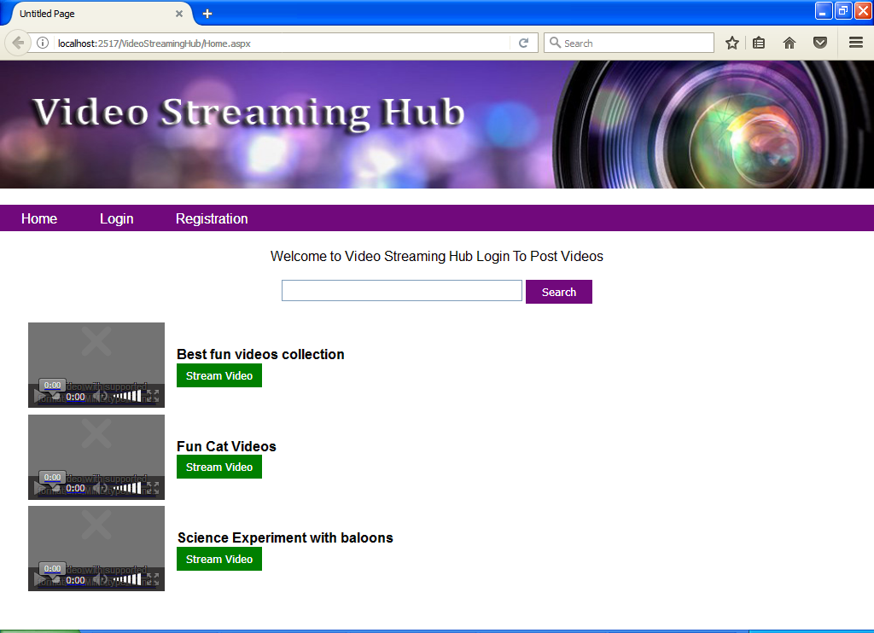
USER REGISTRATION
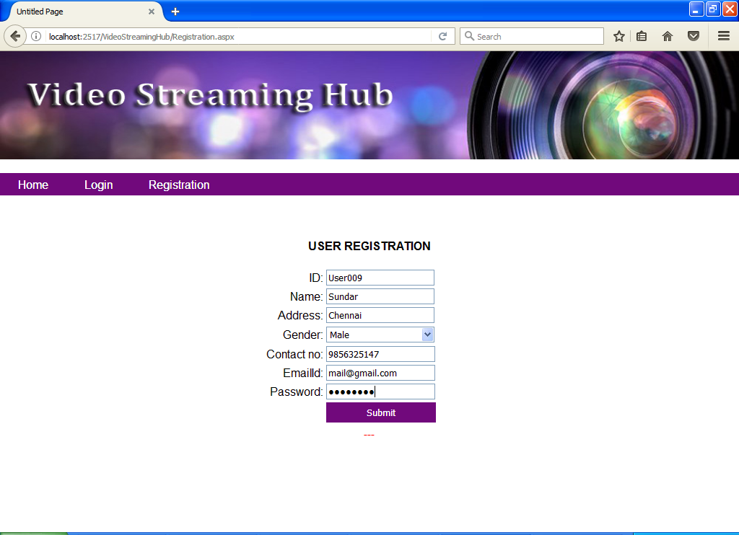
USER LOGIN
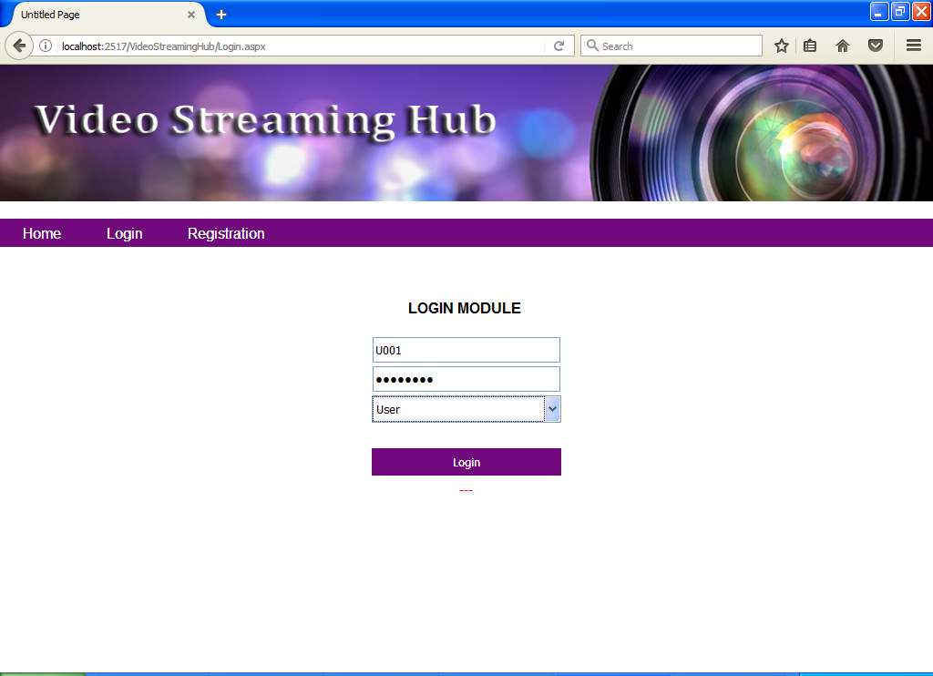
CREATE NEW GROUP
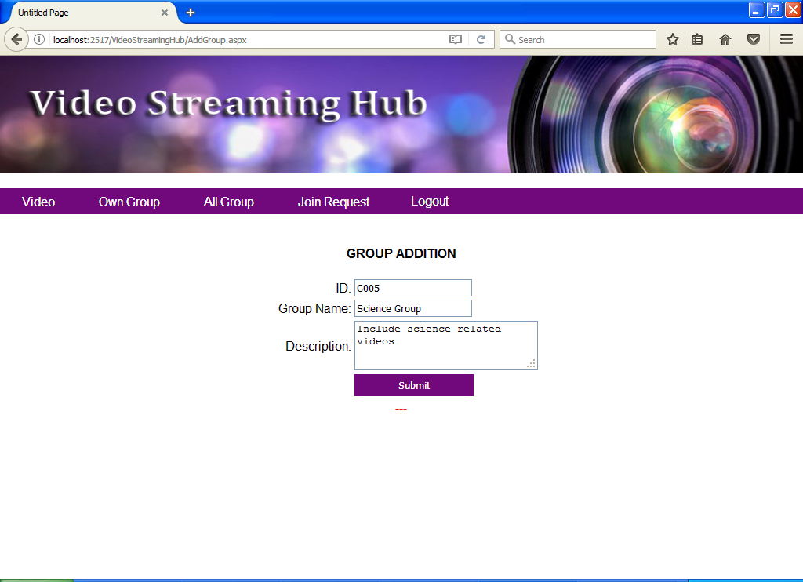
ADMIN LOGIN
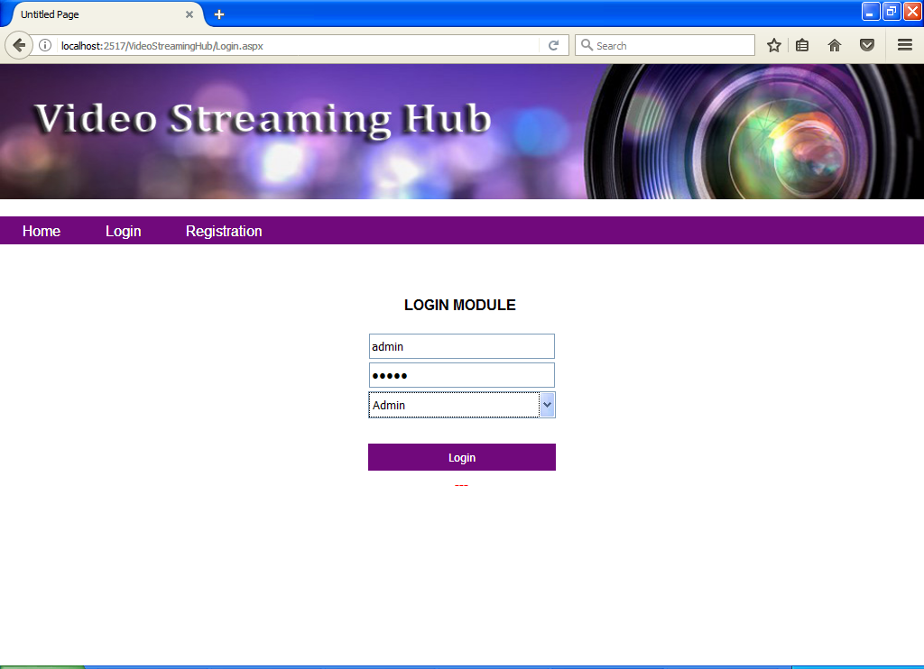
APPROVE/REJECT GROUP CREATION REQUEST
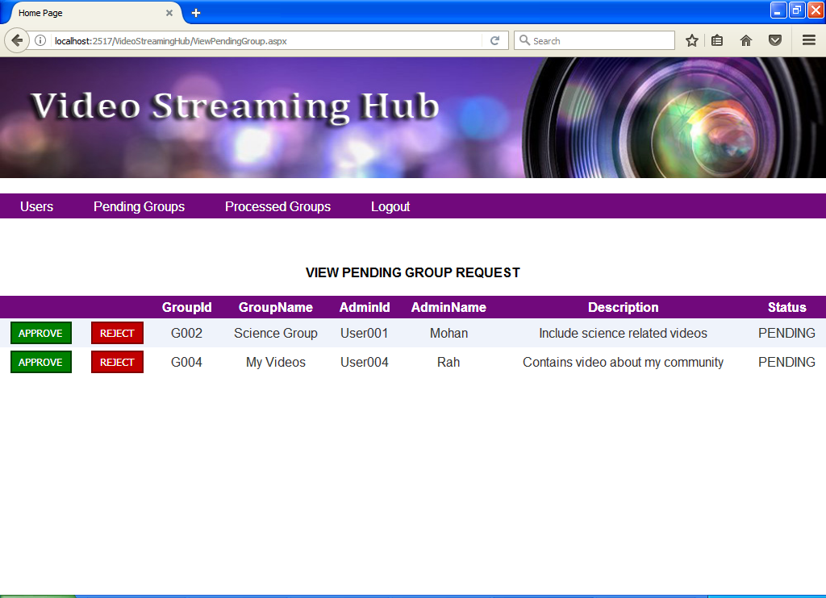
PROCESSED GROUPS
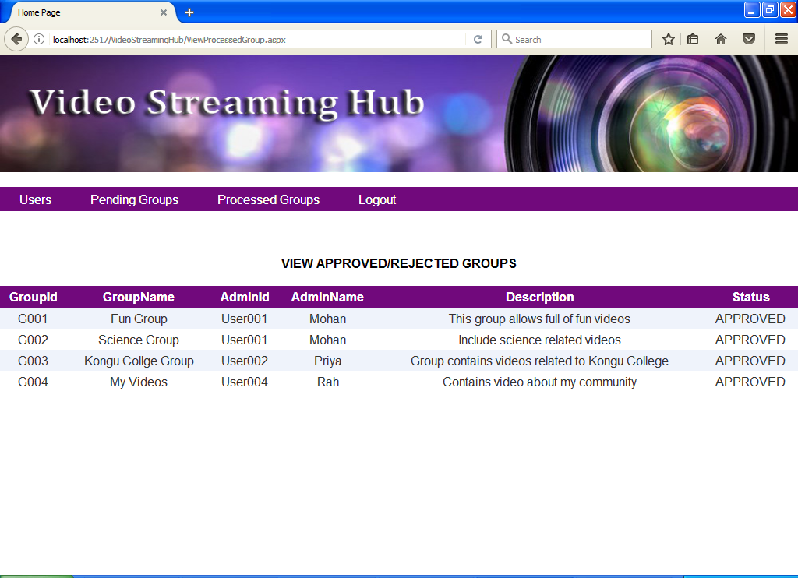
REGISTERED USERS
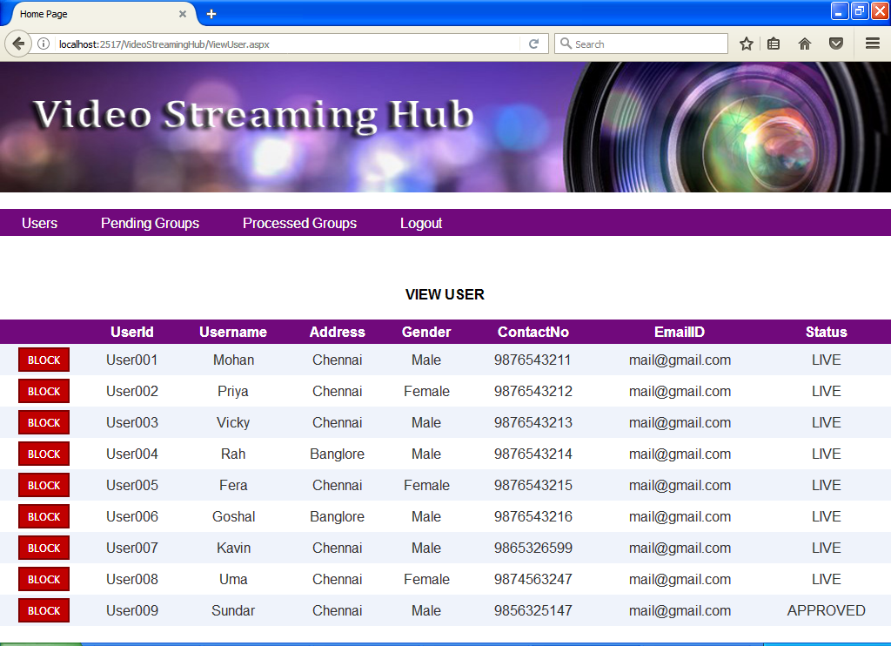
UPLOAD VIDEO IN GROUP
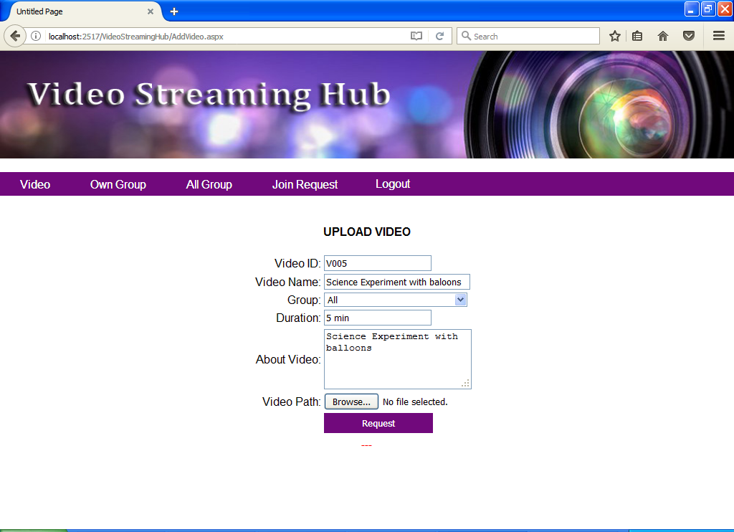
STREAM /TAG VIDEO
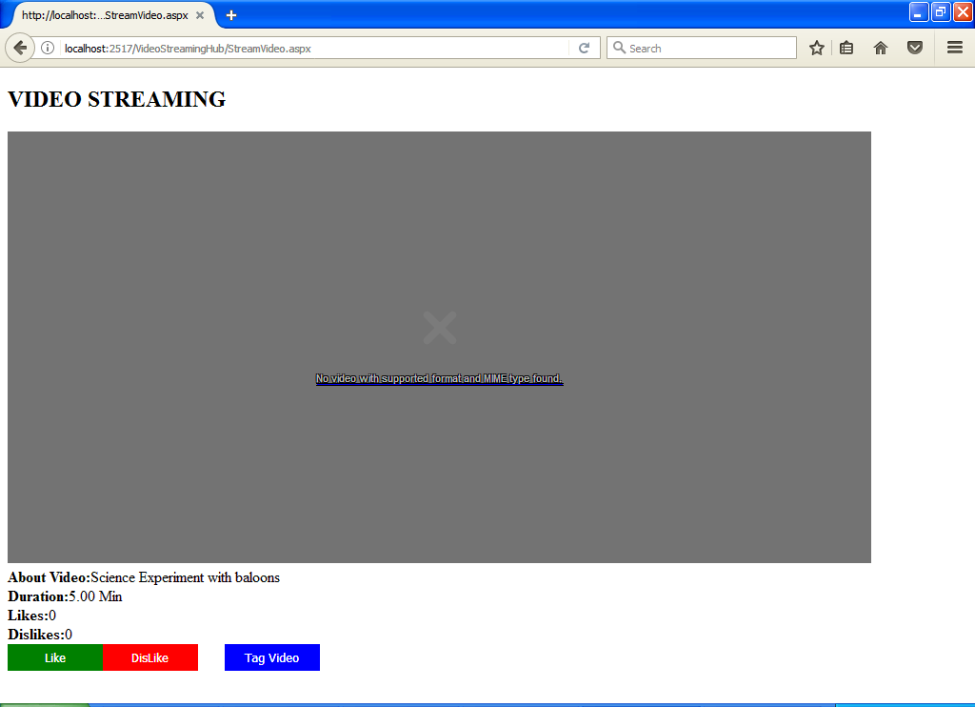
SEARCH ALL GROUP
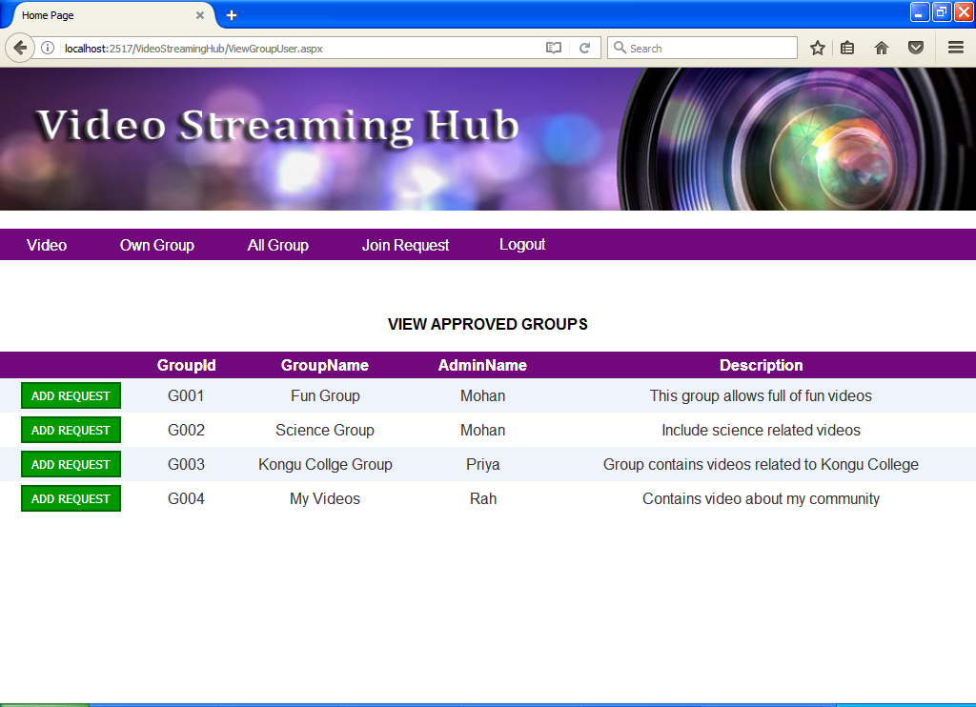
SEND REQUEST TO GROUP ADMIN
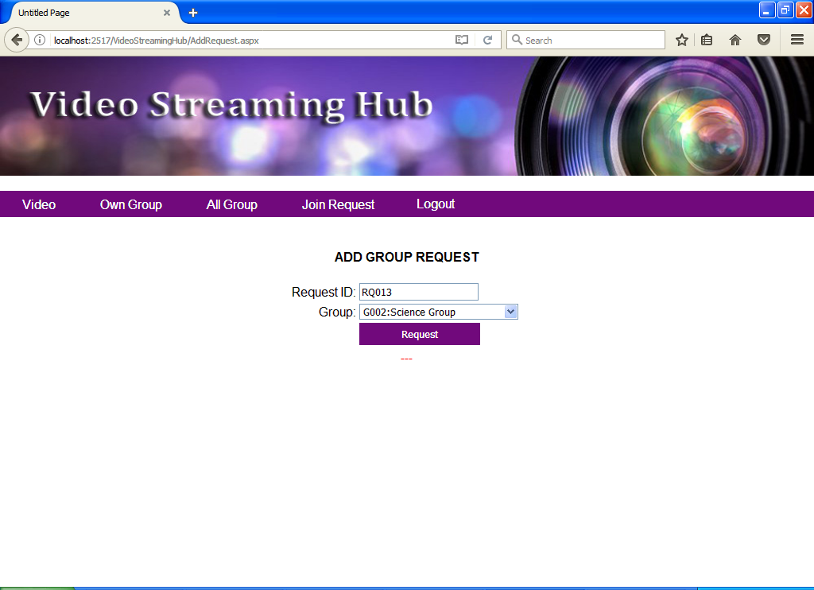

D. SAMPLE CODING
REGISTRATION

Partial Class Registration
Inherits System.Web.UI.Page

Protected Sub Page_Load(ByVal sender As Object, ByVal e As System.EventArgs) Handles Me.Load
If IsPostBack = False Then
RefAll()
End If
End Sub

Private Sub RefAll()
txtID.Text = ""
txtName.Text = ""
ddGender.SelectedIndex = 0
txtContactNo.Text = ""
txtEmailId.Text = ""
txtPassword.Text = ""
txtAddress.Text = ""
Db.cmd.CommandText = "Select COUNT(*)+1 From UserTable"
If Integer.Parse(Db.cmd.ExecuteScalar().ToString()) = 0 Then
txtId.Text = "User001"
Else
txtId.Text = "User" & Integer.Parse(Db.cmd.ExecuteScalar().ToString()).ToString("000")
End If
End Sub

Protected Sub btnSubmit_Click(ByVal sender As Object, ByVal e As System.EventArgs) Handles btnSubmit.Click
Try
Db.cmd.CommandText = "Insert Into UserTable Values('" & txtID.Text & "','" & txtName.Text & "','" & ddGender.Text & "','" & txtAddress.Text & "','" & txtContactNo.Text & "','" & txtEmailId.Text & "','" & txtPassword.Text & "','APPROVED')"
Db.cmd.ExecuteNonQuery()
RefAll()
lblStatus.Text = "Registration Successfull!"
Catch ex As Exception
lblStatus.Text = ex.Message.ToString()
End Try
End Sub

End Class

UPLOAD VIDEO

Imports System.IO
Imports System.Data
Imports System.Data.SqlClient

Partial Class AddVideo
Inherits System.Web.UI.Page

Protected Sub Page_Load(ByVal sender As Object, ByVal e As System.EventArgs) Handles Me.Load
If IsPostBack = False Then

Db.cmd.CommandText = "Select DISTINCT GroupId, GroupName From GroupTrans Where UserId = '" & Session("username") & "' "
Dim r As SqlDataReader = Db.cmd.ExecuteReader
ddGroup.Items.Add("All")
While r.Read
ddGroup.Items.Add(r(0) & ":" & r(1))
End While
r.Close()

RefAll()

If Db.tmp <> "" Then
Db.cmd.CommandText = "Select GroupName From GroupMaster Where GroupID = '" & Db.tmp & "' "
Dim group_name As String = Db.cmd.ExecuteScalar
ddGroup.SelectedValue = Db.tmp & ":" & group_name
Db.tmp = ""
End If

End If
End Sub

Private Sub RefAll()
txtID.Text = ""
txtAboutVideo.Text = ""
txtDuration.Text = ""
txtName.Text = ""
ddGroup.SelectedIndex = 0
Db.cmd.CommandText = "Select COUNT(*)+1 From VideoTable"
If Integer.Parse(Db.cmd.ExecuteScalar().ToString()) = 0 Then
txtID.Text = "V001"
Else
txtID.Text = "V" & Integer.Parse(Db.cmd.ExecuteScalar().ToString()).ToString("000")
End If
End Sub

Protected Sub btnSubmit_Click(ByVal sender As Object, ByVal e As System.EventArgs) Handles btnSubmit.Click
Try

If FileUpload1.HasFile = False Then
lblstatus.Text = "Browse for Video"
Return
End If

Db.cmd.CommandText = "Select Status From UserTable Where UserId = '" & Session("username") & "' "

If Db.cmd.ExecuteScalar() = "BLOCKED" Then
lblstatus.Text = "Your Account has been Blocked!"
Return
End If

Db.cmd.CommandText = "Select Username From UserTable Where UserId = '" & Session("username") & "' "
Dim user_name As String = Db.cmd.ExecuteScalar

Dim file_name As String = txtID.Text & Path.GetExtension(FileUpload1.PostedFile.FileName)
FileUpload1.PostedFile.SaveAs(Server.MapPath(".") & "/Uploads/" & file_name)

Db.cmd.CommandText = "Insert Into VideoTable Values('" & txtID.Text & "','" & txtName.Text & "','" & ddGroup.Text.Split(":")(0) & "','" & Session("username") & "','" & user_name & "','" & DateTime.Now.ToString("MM/dd/yyyy hh:mm:ss tt") & "','" & txtDuration.Text & "','" & txtAboutVideo.Text & "','" & file_name & "',0,0)"
Db.cmd.ExecuteNonQuery()
RefAll()
lblstatus.Text = "Video Added Successfull!"
Catch ex As Exception
lblstatus.Text = ex.Message.ToString()
End Try
End Sub
End Class

